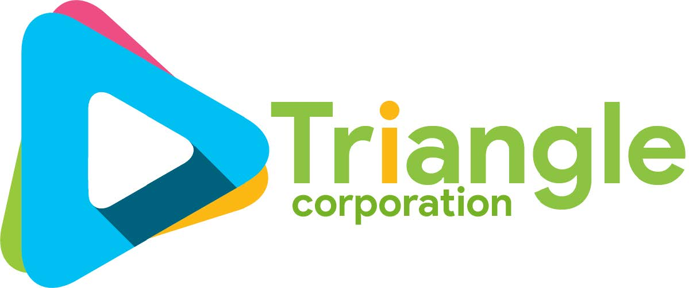

.



Project proposal

Team: 03

Presented by: Team TestRight

TrIANGLE CORPORATION

Team members

1. Akshay Jain – 201812001
2. Pratibha Hotwani – 201812007
3. jaideep warrier - 201812016
4. MOhit Tanwani – 201812023
5. Chirag Chatwani – 201812036
6. ankit chawla – 201812047
7. vishal tanwani – 201812088
8. haresh samnani – 201812092
9. Soniya Vasyani – 201812105

10. Riya SHarma – 201812111

Abstract

TestRight - Exam Tools, i.e our system can be used for conducting different examinations online with security measures to prevent any cheating.It is a digital platform that centralizes the examination process for different exams.

sITE vIEW

1. admin
2. Client

Actors

1. Admin
2. Student
3. teacher

workflow

1. Admin
   1. ALL THE RIGHTS ARE IN THE HANDS OF THE ADMIN.
   2. THE ADMIN CAN BLOCK A SPECIFIC USER.
   3. THE ADMIN HAS THE RIGHTS TO CREATE/EDIT/DELETE A QUIZ.
   4. THE MARKSHEET CAN BE EDITED BY THE ADMIN.
   5. ALL DASHBOARDS WILL ACCESSABLE TO THE ADMIN.
2. Student
   1. students can access the quiz assigned to them.
   2. the students can access the results when ever needed.
   3. the student dashboard will have all the information related to past and upcoming test.
3. Teacher
   1. The teachers can create test.
   2. the teachers can view the results of the students.
   3. the teachers can edit the questions if required.
   4. the teachers can share the test ID to the students.
   5. the teachers can edit the result if required.

Conclusion

to conclude, we can that our product will help both small-scale and LARGE-SCALE institutes as well as organizations to conduct test in an manner.

Thank you

-team TestRight